**Batch: H DA - 3 Roll No.: 16010122096**

**Experiment No. 2**

|  |
| --- |
| **Title: Implement vector data styling and raster data styling in QGIS** |

# Course Outcome:

# CO2 Apply the data analytics in the field of geospatial system

# Books/ Journals/ Websites referred:

# QGIS Installation Link: <https://www.qgis.org/download/> Version 3.38

# Resources used:

[**https://www.qgis.org/download/**](https://www.qgis.org/download/) ______________________________________________________________________

# Algorithm: Vector data styling

# Open QGIS and Load Vector Data:

# Step 1: Start QGIS and load your vector data (e.g., shapefile, GeoJSON, etc.). Go to Layer-> Add Layer -> Add Vector Layer -> Upload the code file

# 

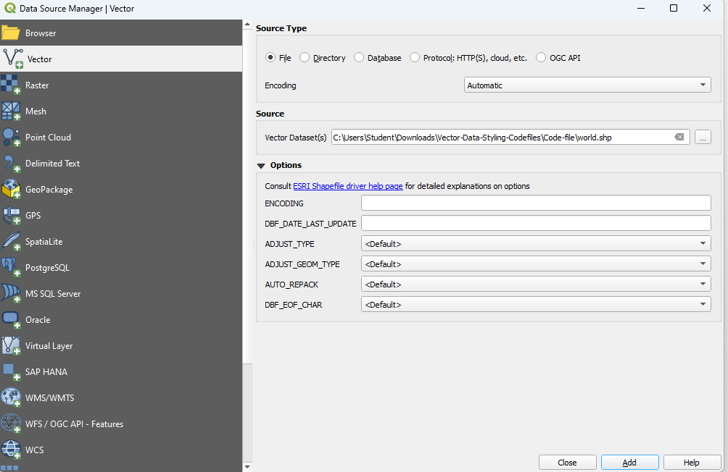

# Step 2: Open the Layer Styling Panel

# 

# Step 3: Select your vector layer in the Layers panel.

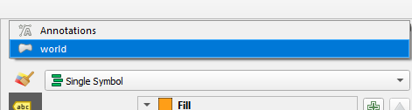

# Step 4: Right-click the layer and choose "Properties" or click on the "Layer Styling" panel on the right.

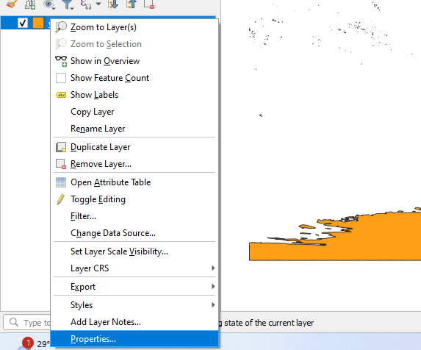

# Step 5: Select a Symbology Type: In the Layer Properties window, go to the "Symbology" tab. Choose a symbology type (e.g., Single Symbol, Categorized, Graduated).

# 

# Step 6: Single Symbol Styling: For simple styling, choose "Single Symbol." Select the symbol and click on the symbol to open the Symbol Selector. Customize the symbol's color, outline, transparency, and other properties.

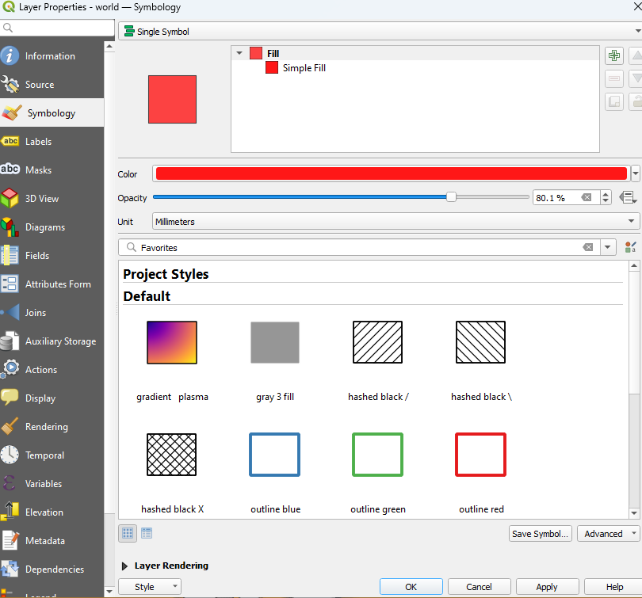

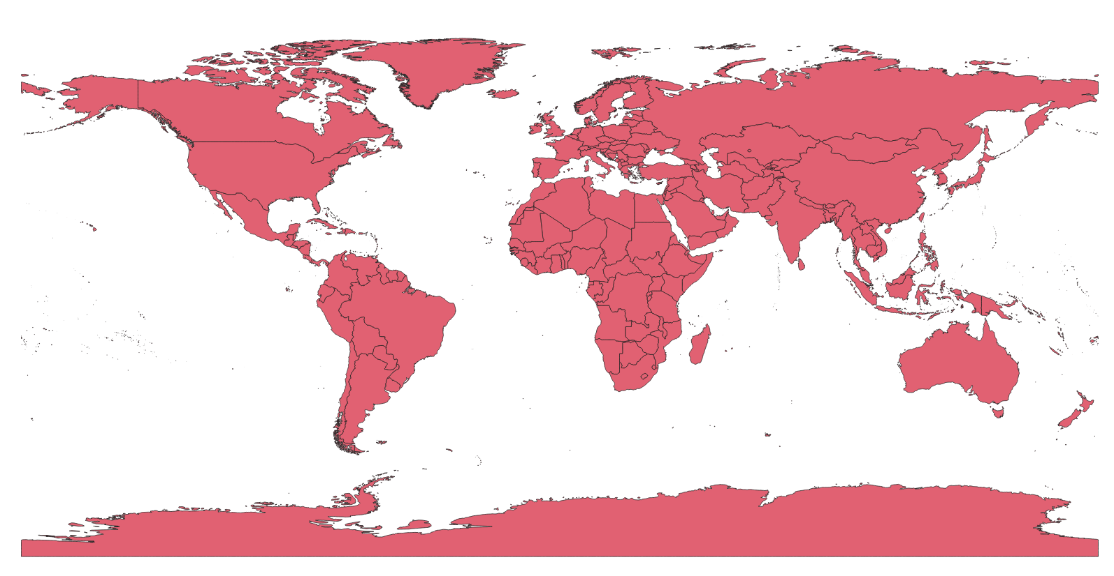

# Step 6: Categorized Styling: Choose "Categorized" to style the layer based on a categorical attribute. Select the attribute column and click "Classify" to generate unique symbols for each category. Customize each category's symbol by clicking on the symbol next to each category.

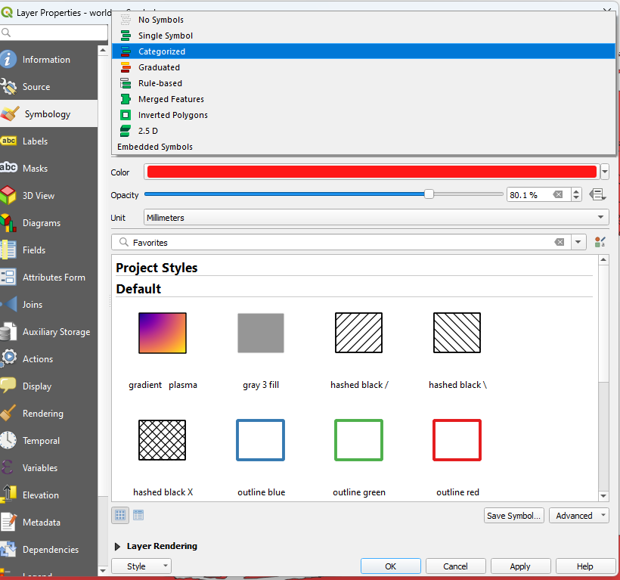

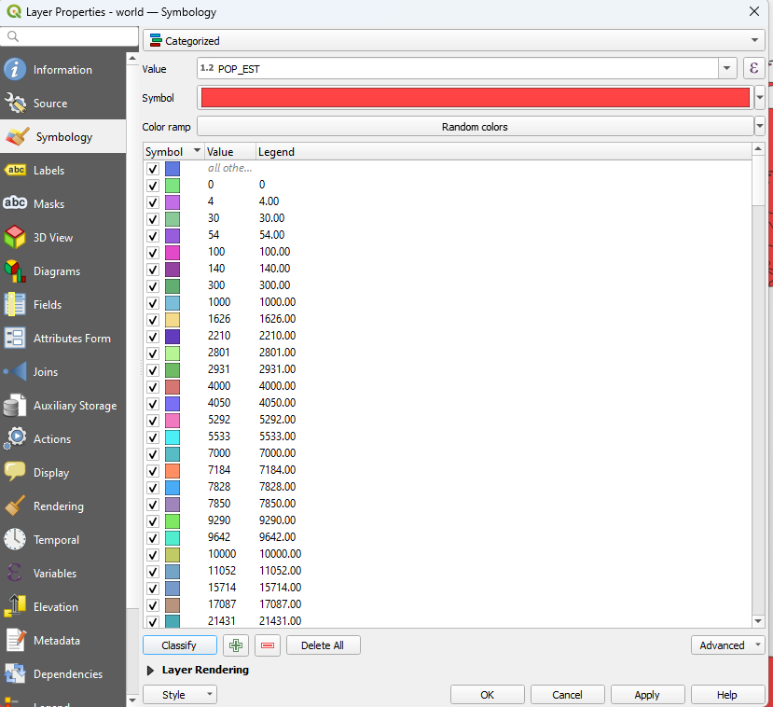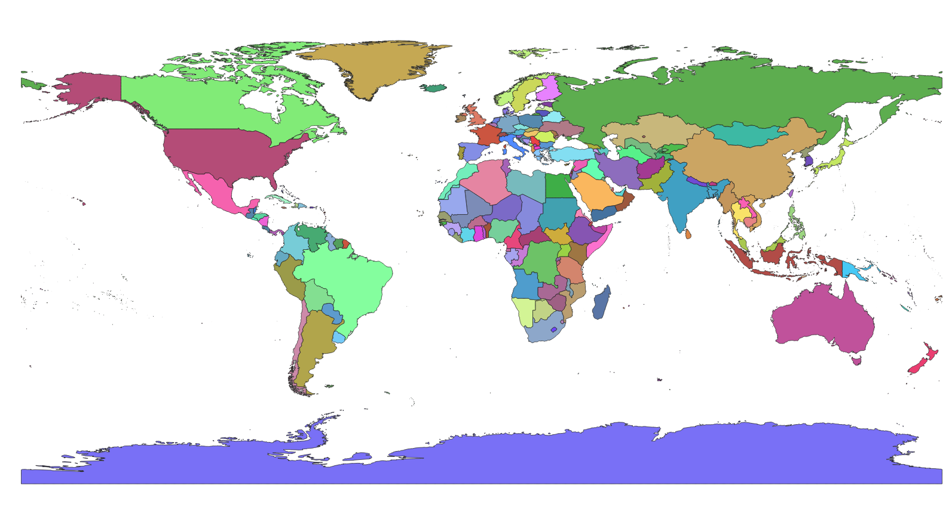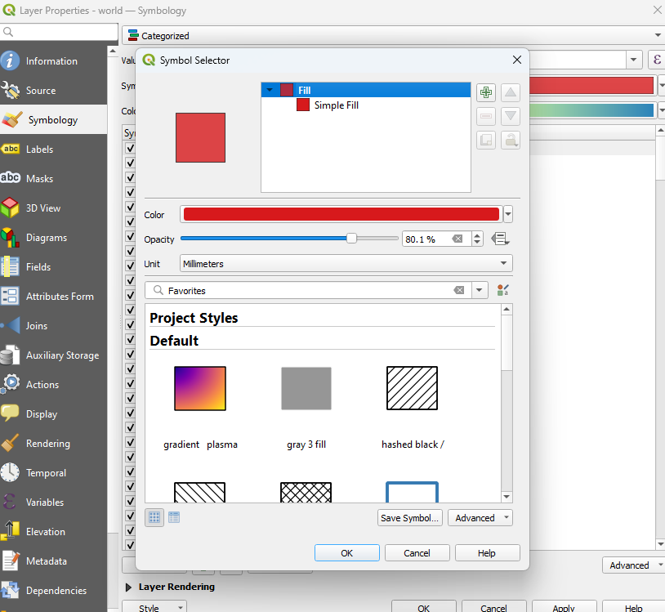

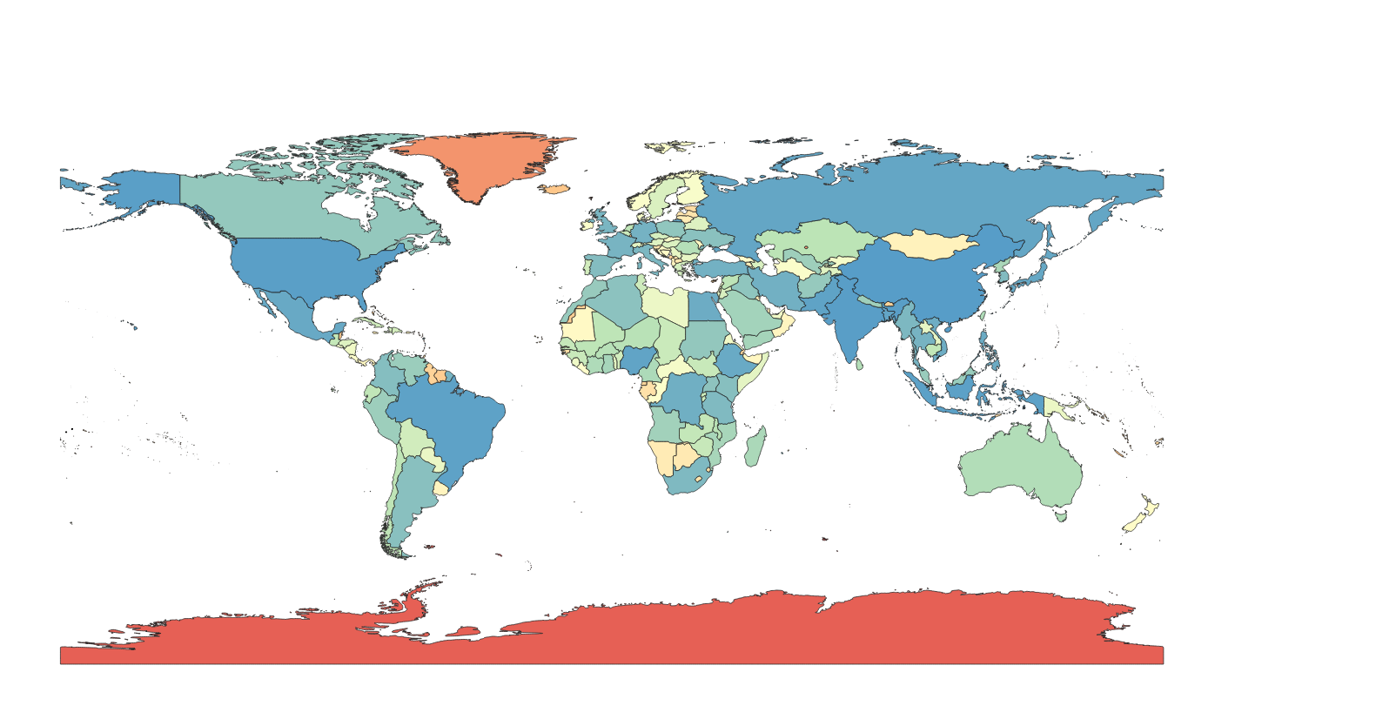

# Step 7: Graduated Styling: Choose "Graduated" to style the layer based on a numeric attribute. Select the attribute column and the classification mode (e.g., Equal Interval, Quantile). Click "Classify" to generate ranges and corresponding symbols. Customize each range's symbol by clicking on the symbol next to each range.

# 

# 

# Algorithm: Raster data styling

# Step 1 : Start QGIS and load your raster data (e.g., GeoTIFF, JPEG, etc.).

# 

# 

# Step 2 : Open the Layer Styling Panel:

# 

# Step 3 : Select your raster layer in the Layers panel. Right-click the layer and choose "Properties" or click on the "Layer Styling" panel on the right.

# 

# 

# Step 4 : Select a Render Type: In the Layer Properties window, go to the "Symbology" tab.

# 

# Step 5: Choose a render type (e.g., Singleband gray, Singleband pseudocolor).

# Step 6 : Singleband Gray: For grayscale images, choose "Singleband gray." Adjust the Min and Max values or use the "Load Min/Max Values" button. Choose a Contrast Enhancement mode (e.g., Stretch to MinMax, Stretch and Clip to MinMax).

# 

# Step 7 : Singleband Pseudocolor: For continuous data, choose "Singleband pseudocolor." Select a color ramp and adjust the Min and Max values. Click "Classify" to generate a color map based on the selected color ramp.

# 

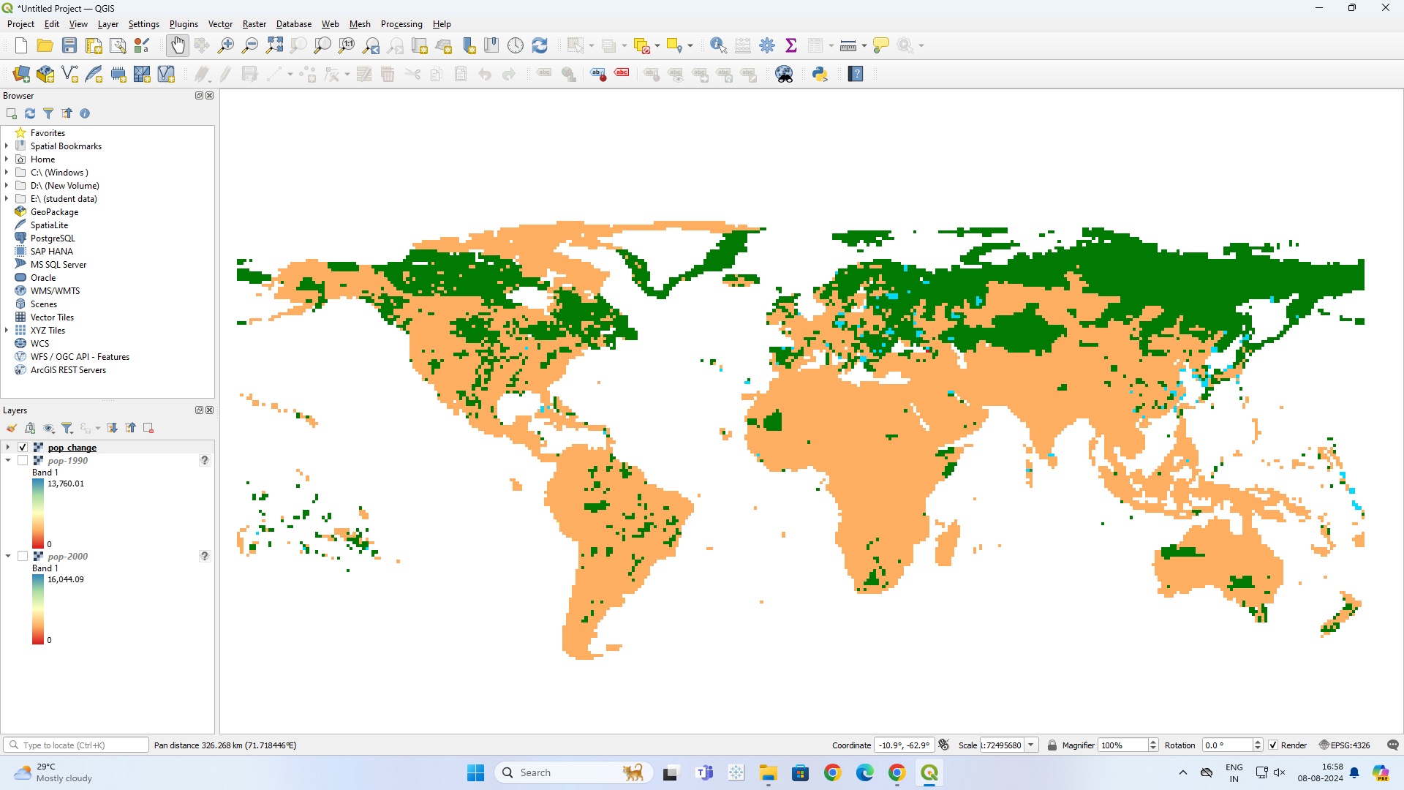

**Task: Install QGIS Software version 3.38. Select different features and perform the vector data and raster data styling. Insert the output images for the respective task.**

# Platform used by the student: QGIS

# Following points should be written by students

# Different steps in Vector data styling and raster data styling

# Students need to write comments wherever needed

1. **Load the Raster Data**:
   * **Step**: Import your raster data (e.g., satellite imagery, elevation models) into your GIS software.
   * **Comment**: Verify the data resolution and projection are appropriate for your analysis.
2. **Choose the Raster Layer to Style**:
   * **Step**: Select the raster layer you want to apply styling to.
   * **Comment**: Confirm the correct layer is selected to avoid applying styles to the wrong data.
3. **Select Styling Method**:
   * **Step**: Decide on the styling approach (color ramp, classified ranges, etc.).
   * **Comment**: Choose based on the type of data and the desired visualization (e.g., continuous vs. discrete data).
4. **Apply Color Ramps or Gradients**:
   * **Step**: Set up a color ramp or gradient to represent the range of values in the raster data.
   * **Comment**: Ensure the color gradient is intuitive and accurately represents data variations.
5. **Classify Raster Values**:
   * **Step**: Group raster values into classes if needed, and assign different colors to each class.
   * **Comment**: This method is useful for discrete data or when simplifying complex data.
6. **Adjust Transparency and Blending**:
   * **Step**: Modify transparency settings to overlay raster data on top of other layers or adjust blending modes.
   * **Comment**: Ensure overlays do not obscure important details in other layers.
7. **Review and Refine**:
   * **Step**: Inspect the styled raster layer for clarity and effectiveness. Make adjustments as necessary.
   * **Comment**: Check that the styling accurately represents the data and is easy to interpret.
8. **Save and Export**:
   * **Step**: Save your styled raster layer and export the map as needed.
   * **Comment**: Verify that the final export maintains the intended style and quality.

Top of Form

Bottom of Form

# Conclusion (Students should write in their own words):

Learned to Implement vector data styling and raster data styling in QGIS

**Post lab questions:**

**Q.1 How do different symbolization methods (e.g., simple symbols, graduated symbols, categorized symbols) impact the interpretation of vector data?**

Different symbolization methods influence how features are perceived on a map. **Simple symbols** use uniform shapes and colors, making them easy to understand but lacking detail. **Graduated symbols** vary in size or color based on numerical attributes, allowing for easy comparison of quantitative differences. **Categorized symbols** use different shapes or colors for various categories, helping to distinguish and interpret different types of features more effectively.

**Q.2 How can attribute data be used to style vector layers effectively (e.g., using different colors for different categories or sizes based on numerical values)?**

Attribute data can enhance vector layer styling by using **categorical attributes** to assign different colors or symbols to various categories, improving feature differentiation. **Quantitative attributes** can be visualized with graduated symbols or color gradients to represent numerical values, such as population size or income levels, making it easier to compare and interpret data.

**Q.3 Discuss in detail vector data styling and raster data styling.**

**Vector data styling** involves customizing symbols (size, shape, color) for points, lines, and polygons to represent various attributes, allowing for detailed and flexible visualizations. **Raster data styling** uses color ramps or classified ranges to represent continuous data in grid cells, such as temperature or elevation, and is ideal for depicting spatial patterns and variations. Both methods are used together to provide a comprehensive view of geographic information.

Top of Form

Bottom of Form